Network topologies

Q1. Draw a diagram of a bus topology and label all key components, then write one real-world example where this topology might be used.
Ans.
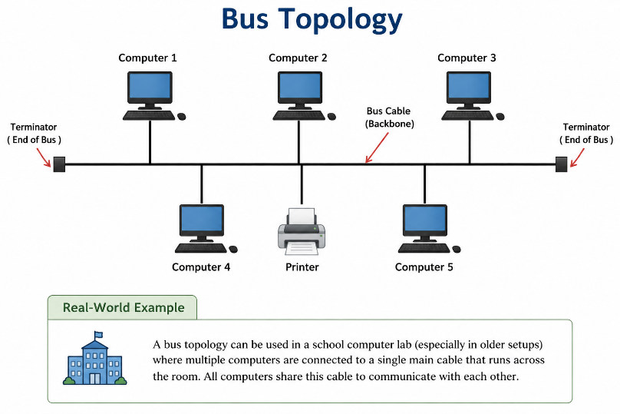
Q2. In Cisco Packet Tracer, create a simple star topology with one switch and four PCs connected to it; name each PC after a popular app (e.g., WhatsApp, Zomato, Spotify, Flipkart) and take a screenshot of your topology.
Ans.
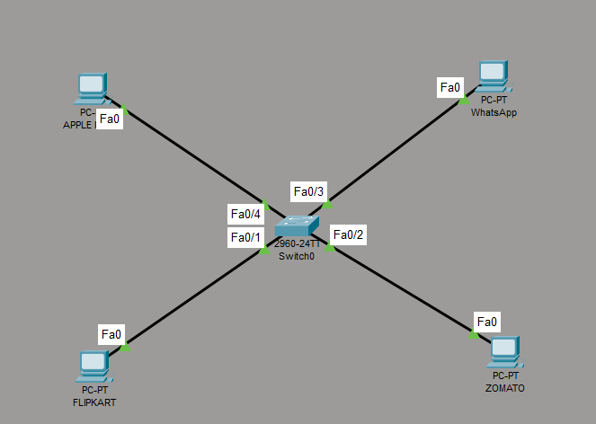
Q3. Draw a ring topology diagram and explain in 2-3 sentences how data travels between devices in this setup. Hint: Use arrows to show the direction of data flow.
Ans.

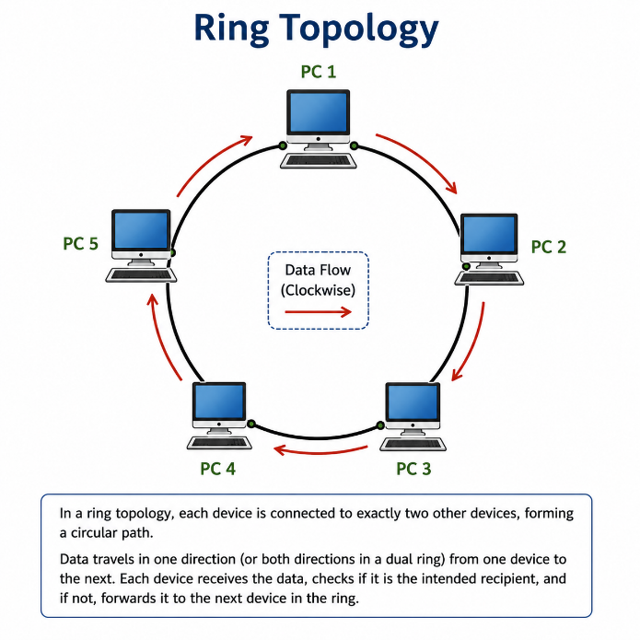
- In a ring topology, each device is connected to exactly two other devices, forming a circular path.
- Data travels in one direction from one device to the next. Each device checks whether it is the intended recipient; if not, it forwards the data to the next device in the ring.
Q4. Compare mesh and star topologies by listing 2 advantages and 2 disadvantages of each in a table format.
Ans. Advantages of Mesh Topology:
1. Very reliable because there are multiple paths.
2. Failure of one connection does not usually affect the others.
Disadvantages:
1. Expensive due to many cables and connections.
2. Difficult to install and maintain.
Advantages of Star Topology:
1. Easy to install and manage.
2. Failure of one device/cable does not affect the whole network.
Disadvantages:
1. If the central switch/hub fails, the whole network goes down.
2. Requires more cable than bus topology.

